Name Of The Student | Garima Modiyani
Internship Project Topic | TCS iON RIO-210: Build a Classification Model for Drug Trials Dataset
Name of the Organization | TCS iON
Name of the Industry Mentor | jignasha royala
Name of the Institute | Amity University

Date | Day | Hours Spent
23-10-2025 | Day-20 | 4 hours 40 minutes
Learn about the accuracy checking of Machine learning models.

What is Accuracy?

Accuracy is one metric for evaluating classification models. Informally, accuracy is the fraction of predictions our model got right. Formally, accuracy has the following definition:
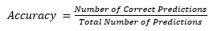
For binary classification, accuracy can also be calculated in terms of positives and negatives as follows:
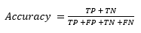
Where TP = True Positives, TN = True Negatives, FP = False Positives, and FN = False Negatives.
Where there are only 2 classes, positive & negative:

TP : True Positives i.e. positive classes that are correctly predicted as positive.
FP : False Positives i.e negative classes that are falsely predicted as positive.
TN : True Negatives i.e. negative classes that are correctly predicted as negative.
FN : False Negatives i.e positive classes that are falsely predicted as negative.

Accuracy is the best known evaluation metric for classification, it might not always be enough while working with real life datasets.

Other important evaluation metrics for classification includes:

- Precision
- Recall
- AUC/ROC curve
- F Score

Precision :

Precision is defined as the fraction of relevant examples (true positives) among all of the examples which were predicted to belong in a certain class.

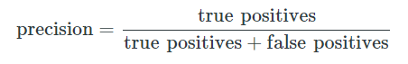
Recall:

Recall is defined as the fraction of examples which were predicted to belong to a class with respect to all of the examples that truly belong in the class.

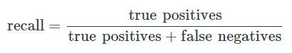

ROC curve

An ROC curve (receiver operating characteristic curve) is a graph showing the performance of a classification model at all classification thresholds. This curve plots two parameters:

- True Positive Rate
- False Positive Rate

True Positive Rate (TPR) is a synonym for recall and is therefore defined as follows:

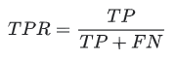

False Positive Rate (FPR) is defined as follows:

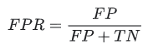

An ROC curve plots TPR vs. FPR at different classification thresholds. Lowering the classification threshold classifies more items as positive, thus increasing both False Positives and True Positives.

The following figure shows a typical ROC curve.

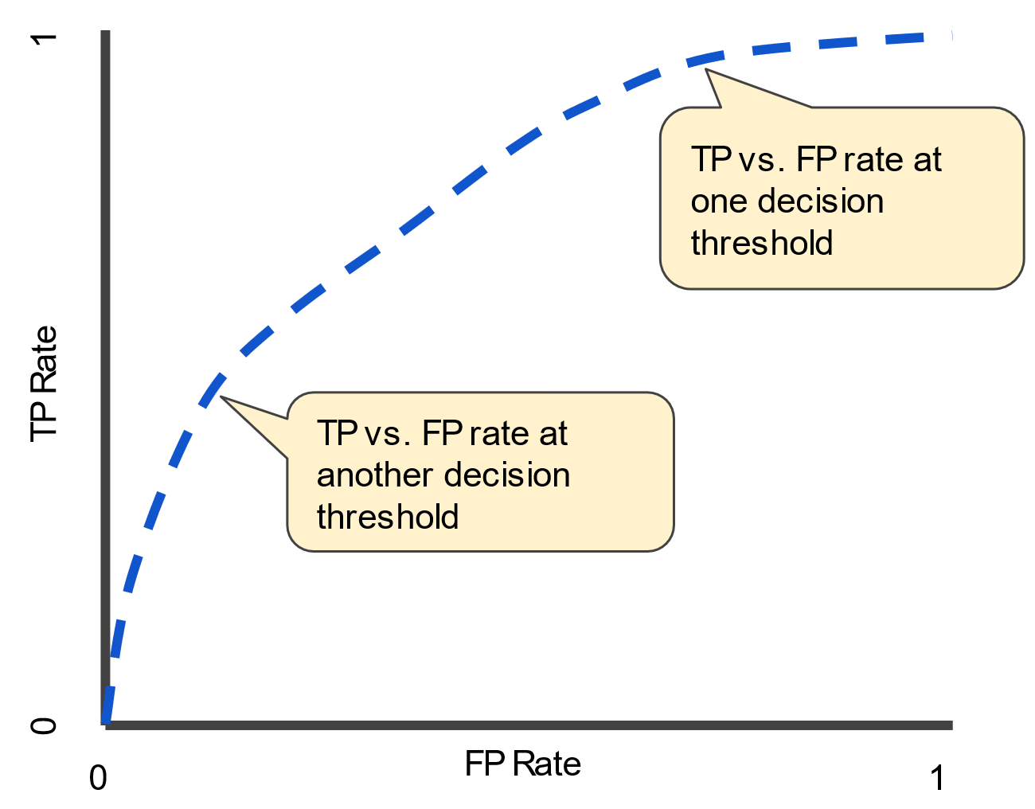

AUC: Area Under the ROC Curve

AUC stands for "Area under the ROC Curve." That is, AUC measures the entire two-dimensional area underneath the entire ROC curve (think integral calculus) from (0,0) to (1,1).

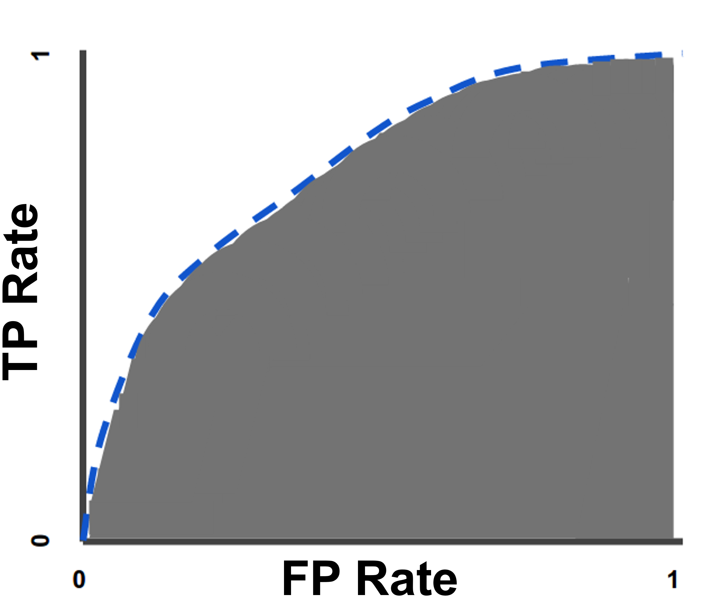

AUC provides an aggregate measure of performance across all possible classification thresholds. One way of interpreting AUC is as the probability that the model ranks a random positive example more highly than a random negative example. For example, given the following examples, which are arranged from left to right in ascending order of logistic regression predictions:

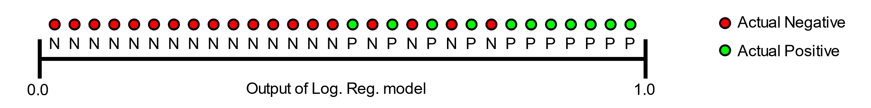

- AUC represents the probability that a random positive (green) example is positioned to the right of a random negative (red) example.

- AUC ranges in value from 0 to 1. A model whose predictions are 100% wrong has an AUC of 0.0; one whose predictions are 100% correct has an AUC of 1.0.

AUC is desirable for the following two reasons:

- AUC is scale-invariant. It measures how well predictions are ranked, rather than their absolute values.
- AUC is classification-threshold-invariant. It measures the quality of the model's predictions irrespective of what classification threshold is chosen.

However, both these reasons come with caveats, which may limit the usefulness of AUC in certain use cases:

- Scale invariance is not always desirable. For example, sometimes we really do need well calibrated probability outputs, and AUC won’t tell us about that.

- Classification-threshold invariance is not always desirable. In cases where there are wide disparities in the cost of false negatives vs. false positives, it may be critical to minimize one type of classification error. For example, when doing email spam detection, you likely want to prioritize minimizing false positives (even if that results in a significant increase of false negatives). AUC isn't a useful metric for this type of optimization.

Reference:

https://www.iguazio.com/glossary/model-accuracy-in-ml/
https://www.analyticsvidhya.com/blog/2019/08/11-important-model-evaluation-error-metrics/
https://neptune.ai/blog/performance-metrics-in-machine-learning-complete-guide

